Contents

Chapter 5 – EigenVales and EigenSpaces 1

5.1 1

Characteristic Equation 1

Chacteristic Equation for a 3 x 3 Matrix 1

Eigen Basis 1

5.2 1

Similar Matrices 1

Diagonalization of a Matrix 1

Chapter 6 – Inner Product Spaces 3

6.1 3

Length / Norm 3

Weighted Product / Stanard Inner Product 3

Unit Circle 3

Find a Matrix that generates The stated Inner Product 3

6.2 4

Angle Between two Vectors 4

Cauchy-Schwarz 4

Orthogonal 4

Orthonormal 4

Orthogonal Matrix 4

Orthogonal Complement 4

6.3 5

Orthonormal BAsis 5

Orthogonal Projections 5

Gram-Schmidt Process 5

QR – Decomposition 6

Confirm that component is Orthogonal to plane. 6

Chapter 7 7

7.1 7

Othogonal Matrix 7

7.2 7

Othogonal Diagonalization 7

7.3 7

Quadratic Form as Matrix 7

Quadratic Form 8

Chapter 4 9

4.4 Coordinates and Basis 9

4.5 Dimensions 9

4.7 Row/Col/Null Space 9

4.8 Rank of a Matrix 9

4.9 Basic Matrix Transformation (Reflection and Orthogonal Projection) 9

4.3 10

# Chapter 5 – EigenVales and EigenSpaces

## 5.1

### Characteristic Equation

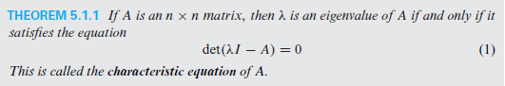

### Chacteristic Equation for a 3 x 3 Matrix

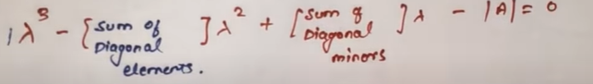

### Eigen Basis

Cramer’s Rule Trick.

## 5.2

### Similar Matrices

Det(A) == Det(B)

### Diagonalization of a Matrix

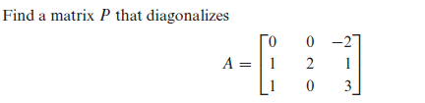

D = P-1AP ; Ak = PDkP-1

D = Matrix with Eigen values in the Diagonals.

P = Matrix with columns formed by eigen basis.

* If Eigen basis does not equal to size of matrix, the matrix is not diagonalizable.

# Chapter 6 – Inner Product Spaces

## 6.1

### Length / Norm





### Weighted Product / Stanard Inner Product



< P, Q > = P.Q

### Unit Circle



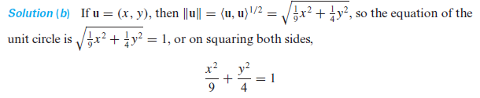

### Find a Matrix that generates The stated Inner Product

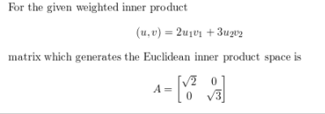

### 6.2

### Angle Between two Vectors

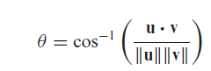

### Cauchy-Schwarz

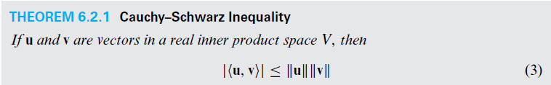

### Orthogonal

Dot Product = 0.

### Orthonormal

Norm = 1.

### Orthogonal Matrix

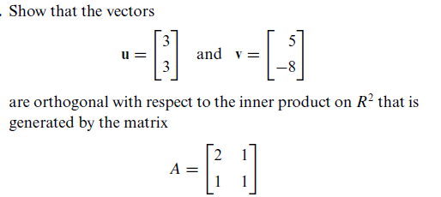

A(u) . A(v) = 0.

### Orthogonal Complement

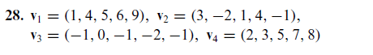

1. Create a Matrix (Row wise)
2. RREF
3. Find the basis.

### 6.3

### Orthonormal BAsis

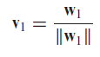

### Orthogonal Projections

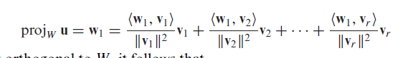

### Gram-Schmidt Process

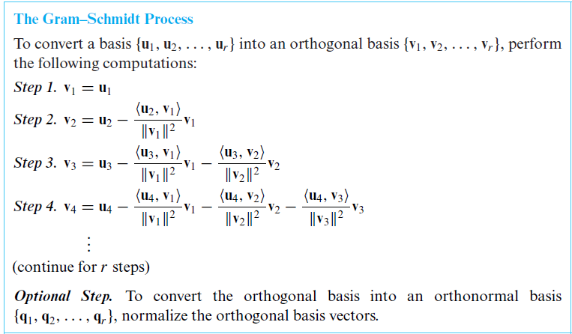

### QR – Decomposition

A = QR

Q:

Columns of a as (u1,u2,u3,…)

Apply Gram-Schmidt Process.

Use (v1,v2,v3,…) to for a Matrix.

That Matrix = Q.

R = QTA.

### Confirm that component is Orthogonal to plane.

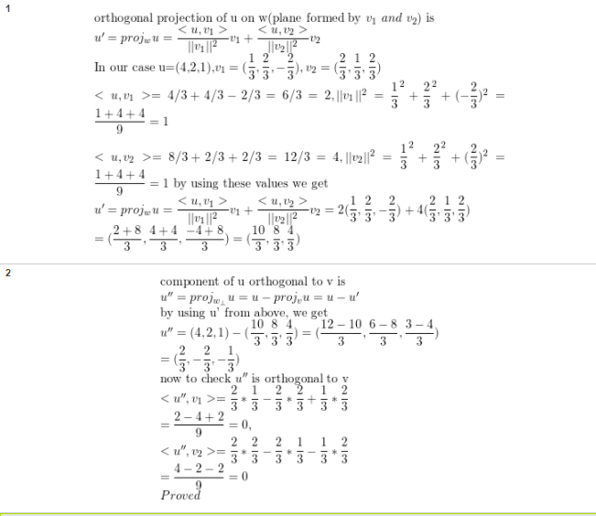

# Chapter 7

## 7.1

### Othogonal Matrix

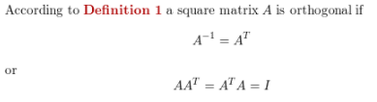

## 7.2

### Othogonal Diagonalization

D = P-1AP

1. Find Eigen Spaces/Vector using Lambda.
2. Gram-Schmidt on Eigen Spaces.

P = {v1,v2,…,} Matrix

D = Eigen Values in Diagonals.

A = Main Matrix.

## 7.3

### Quadratic Form as Matrix

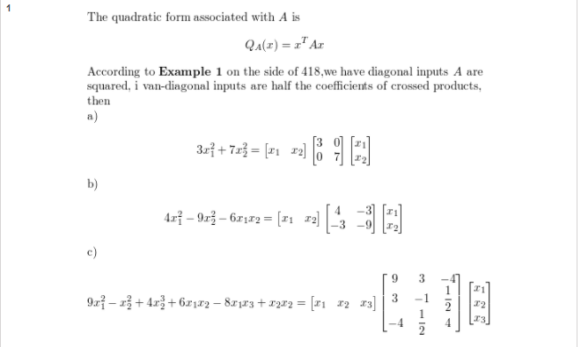

### Quadratic Form

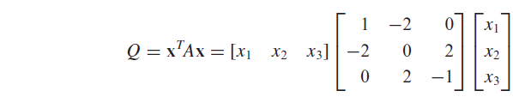

Q = PTAP

1. Find Eigen Spaces/Vector using Lambda.
2. Gram-Schmidt on Eigen Spaces.

P = {v1,v2,…,} Matrix

D = Eigen Values in Diagonals.

A = Main Matrix.

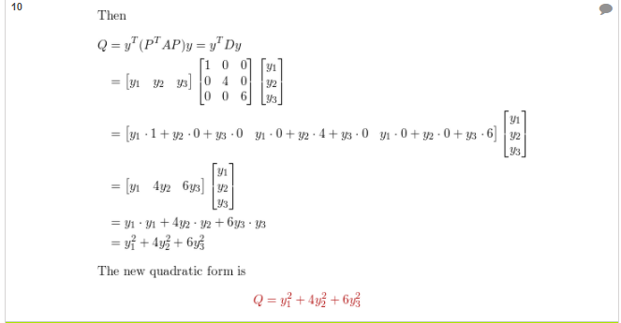

# Chapter 4

## 4.4 Coordinates and Basis

Not a basis: Det(A) = 0.

* Basis:

1. Det(A) != 0.
2. Linearly Independent: Pivot in every Col.
3. Spanning: Pivot in every row.

Show that a Matrices do not form a basis:

Add Aij of each matrix and make augmented matrix from the equation, then evaluate for values.

* Co-ordinates:

1. v1,v2,v3 | v 🡪 Matrix.
   1. Answer of v by RREF, are the coordinates.

## 4.5 Dimensions

Dimension = Basis of a Matrix.

1. Convert the Matrix into REF.
2. Find Basis.

## 4.7 Row/Col/Null Space

1. Row Space: Non-Zero rows, after REF.
2. Col: Non – Zero cols having pivots, after REF.
   1. Check, including b (x1,x2,x3) in the matrix, is in Col space of a Matrix:
      1. REF 🡪 If there is a col with no Pivot (3x3), b is not in col space.
3. Null Space:
   1. Basis of a REF matrix.
4. AX=b 🡪 Simply Solve for x values in the form of basis.
5. Ax = 0 🡪 Remove first col of x1.

## 4.8 Rank of a Matrix

Rank/Leading Variables = Rows with Pivot.

Nullity/Parameters = No. of Cols – Rank.

Rank + Nullity = Size of Matrix (Formula 4)

## 4.9 Basic Matrix Transformation (Reflection and Orthogonal Projection)

Reflection:

1. X-Axis 🡪 Y sign change, and vice versa.
2. XY-Axis 🡪 Z sign change and vice versa.

Orthogonal projection:

1. X-Axis 🡪 Y = 0, and vice versa.
2. XY – Axis 🡪 Z = 0, and vice versa.

Use Matrix Multiplication 🡪 **Rotated about the origin:**

Cos -Sin

Sin Cos

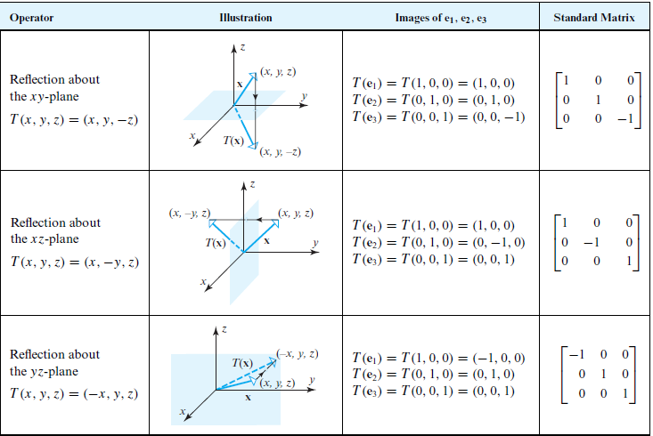

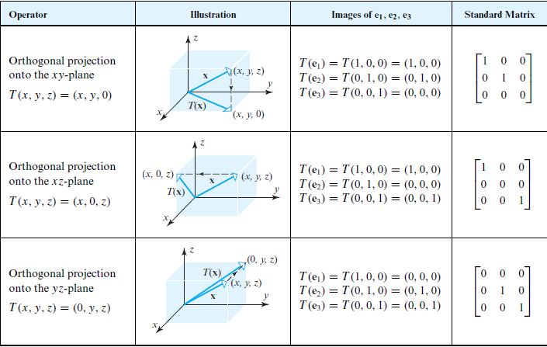

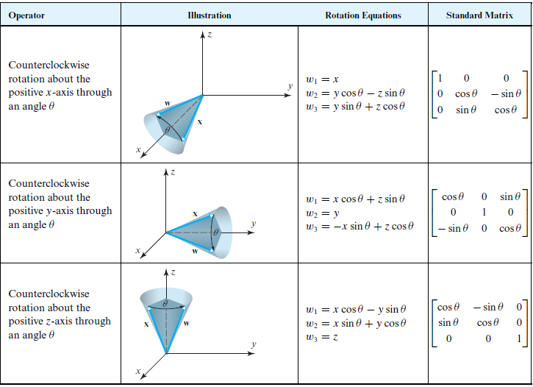

## 4.3

Contradiction



Dilation

